**CSE3011 NETWORK PROGRAMMING**

**LAB EXPERIMENT 9**

NAME – B PRATYUSH

REGISTRATION NUMBER – 19BCN7114

LAB SLOT – L1+L2

FACULTY – PROF. MUNEESWARI

**Experiment Description: Implement Secured Socket Communication between Client and Server**

**Server Side Code**

**SecureServer.java**

import java.util.*;

import java.io.*;

import java.net.*;

class TimeOutTask extends TimerTask {

boolean isTimedOut = false;

public void run() {

isTimedOut = true;

}

}

public class SecureServer {

public static void main(String args[]) throws IOException {

ServerSocket serverSocket = new ServerSocket(7777);

System.out.println("Server running and waiting for client...");

Socket clientSocket = serverSocket.accept();

PrintWriter out = new PrintWriter(clientSocket.getOutputStream(), true);

BufferedReader in = new BufferedReader(new InputStreamReader(clientSocket.getInputStream()));

DataInputStream din=new DataInputStream(clientSocket.getInputStream());

DataOutputStream dout=new DataOutputStream(clientSocket.getOutputStream());

BufferedReader br=new BufferedReader(new InputStreamReader(System.in));

// Server waits for a client to send its user ID

String id = in.readLine();

// Server generates an OTP and waits for client to send this

Random r = new Random();

String otp = new String();

for(int i=0 ; i < 8 ; i++) {

otp += r.nextInt(10);

}

System.out.println(otp);

// Server starts a timer of 10 seconds during which the OTP is valid.

TimeOutTask task = new TimeOutTask();

Timer t = new Timer();

t.schedule(task, 100000L);

// Server listens for client to send its ID and OTP to check if it is

// valid

String newId = in.readLine();

String newOtp = in.readLine();

String str="",str2="";

if(newId.equals(id)) {

// User ID is verified

if(task.isTimedOut) {

// User took more than 100 seconds and hence the OTP is invalid

out.println("Time out!");

} else if(!newOtp.equals(otp)) {

out.println("Incorrect OTP!");

} else {

out.println("Logged In!");

while(!str.equals("stop")){

str=din.readUTF();

System.out.println("client says: "+str);

str2=br.readLine();

dout.writeUTF(str2);

dout.flush();

}

din.close();

}

}

clientSocket.close();

serverSocket.close();

System.exit(0);

}

}

**Client Side Code**

**SecureClient.java**

import java.util.*;

import java.io.*;

import java.net.*;

public class SecureClient {

public static void main(String args[]) throws IOException {

Scanner scan = new Scanner(System.in);

System.out.println("Connecting to the server...");

Socket clientSocket = new Socket("localhost", 7777);

PrintWriter out = new PrintWriter(clientSocket.getOutputStream(), true);

BufferedReader in = new BufferedReader(new InputStreamReader(clientSocket.getInputStream()));

DataInputStream din=new DataInputStream(clientSocket.getInputStream());

DataOutputStream dout=new DataOutputStream(clientSocket.getOutputStream());

BufferedReader br=new BufferedReader(new InputStreamReader(System.in));

// Client enters ID. This will be used by the program for verifying who

// is communicating as well as check the OTP against the ID, on the

// server side

System.out.println("Enter your ID:");

String id = scan.nextLine();

System.out.println("Contacting server...");

out.println(id);

System.out.println("Server has sent the OTP. Please enter it here:");

String otp = scan.nextLine();

System.out.println("Verifying...");

out.println(id);

out.println(otp);

System.out.println(in.readLine());

String str="",str2="";

while(!str.equals("stop")){

str=br.readLine();

dout.writeUTF(str);

dout.flush();

str2=din.readUTF();

System.out.println("Server says: "+str2);

}

dout.close();

in.close();

out.close();

clientSocket.close();

}

}

**Client Side Output**

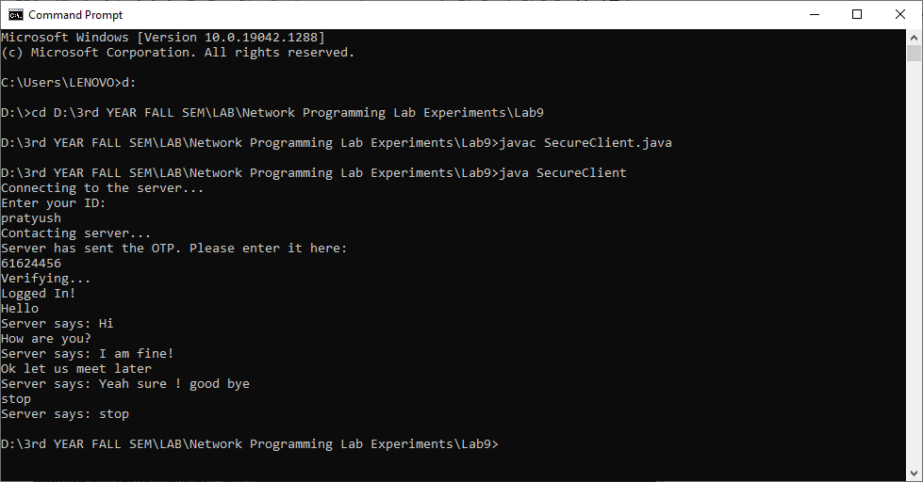

**Server Side Output**

